Monthly Progress Report

Template ver.1.3

Month YYYY

Activity NAME

ESA Contract N.: XXXXX/XX/XX/XX

Date: DD Month YYYY

Period Covered: DD Month YYYY- DD Month YYYY

Author(s): Project Manager Name (Company)
……………

Contributions: Contributor A (Company)
Contributor B (Company)
……………

A. Short monthly status report

Please provide a summary of the activities performed during the reporting period. Please try to follow these guidelines:
- Be concise
- Avoid a report that is too structured (like reporting by each WP)
- Do not keep reporting past issues by adding new things to old ones which are not relevant anymore for the time span covered in the report
- Consider the Monthly Progress Report as a tool not only to keep ESA informed, but the whole project team
- Be systematic; provide the Monthly Progress Report on time, and not only during the first months. Suggestion: put a repeating monthly entry into the electronic calendar of the person responsible for producing the monthly report.
- Include a fixed calendar date when the next project milestone is going to take place

Possible example:
Following the Baseline Design Review (BDR), which took place in the headquarters of the company XXX on 12 March 2017, the Requirement Document has been finalised taking into account the Actions agreed at the BDR meeting.
The hardware design activities have started with the initial selection of the Commercial Off The Shelf (COTS) components required for the development of the user terminal. The CPU selected is XXX and it has been verified that it will be available for purchase for a period of 5 years.
The Business Plan has been reviewed by an external consultant which led us to re-evaluate upwards the number of man hours and costs needed for the installation of each unit. This will be balanced by an increased installation charge for the customer. The Critical Design Review meeting (CDR) is planned to take place at the premises of ZZZ on 18 August 2017.

B. Problems Encountered and Corrective Actions

Please indicate here any problem areas that you encountered and any corrective measures that will be taken. Ensure that a status report on all long lead or critical delivery items is included.

C. Planned Activities for Next Period

Please provide a short summary of the activities to be undertaken for the next period

D. Updated Work Package Status

Please include a table based on the format below for all work packages included in the work breakdown structure.

Work Package Number | Work Package Description | Total Number of Hours Allocated | Approximate % of Allocated Hours Spent | Comments

E. Deliverables Status

Below an example. Use the table that you have submitted in the Full Proposal and agreed at Negotiation Meeting, providing information on the last version submitted and the date

Document |  |  | Review Data Package
Reference | Title | Acronym | RR | PDR | CDR | FAT | SAT | FR
Management
D.MG1 | Configuration and Documentation Management Plan | CMDP | V.1.2. Delivered on 20/03/2022
D.MG2 | Risk Register | RR
D.MG3 | Business Plan | BP |  | V2.0 Delivered on 20/03/2022
D.MG4 | Document List | DL
D.MG5 | Monthly Progress Report | MPR
D.MG7 | Activity Web Page | AWP
D.MG9 | Digital Media | DM
D.MG11 | Contract Achievements and Socio Economic Impact Questionnaire | CA-SEIQ
D.MG12 | Product Data Sheet | PDS
D.MG13 | Final Data Package | FDP
D.MG14 | Final Report | FREP
Engineering
D.EN1 | Customer Segment Problems/Needs | CSN
D.EN2 | Technical Requirements Specification / | TRS
 | Product Specification
D.EN3 | Requirements Traceability Matrix | RTM
D.EN4 | Compliance Matrix to Technical Specification | CMTS
D.EN5 | Design Verification Compliance Matrix | DVCM
D.EN6 | Design Definition File | DDF
D.EN7 | Design Justification File | DJF
D.EN8 | Trade-Off Report | TOR
D.EN9 | User Manual | UM
Testing
D.TE1 | Test Specification | TSPE
D.TE2 | Test Procedure | TPRO
D.TE3 | Test Report | TRPT
D.TE4 | Validation Plan | VP
D.TE5 | Validation Report | VREP

F. Planning
If you use a Project Management Software, please provide here the link of the file (e.g the Microsoft Project .mpp file uploaded on the activity portal). In case you do not have/use it you can provide an update planning e.g. like that one in the image below.

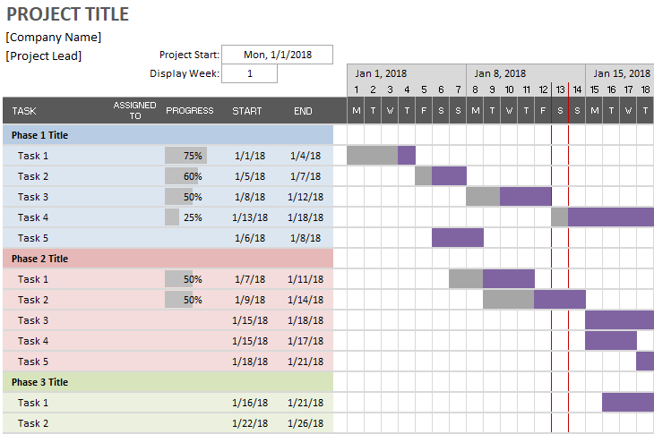

Furthermore, add a table when the contractual milestones are listed with the original date (on the contract) and the expected one.

Milestone | Planned (in the contract) | Expected (or Actual)
KO
MS1/CDR
MS2/AR
MS3/FR

G. Updated Risk Table

Please provide a table listing major foreseen project risks (both managerial & technical) to include risk description, likelihood, impact / severity, and mitigation actions.

H. Marketing Plan / Business related activities / Investors

Please provide a short summary of the marketing / business related activities undertaken in the last period, including web stories on websites, Google AdSense, giving presentations at exhibitions, stand at exhibition(s), production of brochures. Let us also know any new contact with possible customers and any agreement secured related to the activity.
Inform us if you have contacted or secured agreements with any investor.

Possible example:
In April 2017 the company XXX participated to the European Workshop for Hyperspectral sensors, where a presentation of the project was delivered. A follow-up meeting took place with a potential customer based in Ireland, which expressed a potential interest for 20 sensors. The web site of the product has been revised, which offers now a sample images of the product AAAA. In the last month according our web stats package images have been downloaded on 100 times.
The product brochure has been finalised and a first batch of 150 prints have been produced.
The company BBB will participate in the Hamburg events of 28-30 October 2017, where the product will be presented in the stand co-hosted with our strategic partner CCC.

H. Current Status Update for the Activity Web Page under the InCubed Site

This paragraph will be used to update the current status of the Activity Web Page, which will be published on the ESA InCubed Web Site. Please remember that this paragraph (that you provide here) will be made public!

This paragraph shall be provided whenever the project has significant achievements to report (e.g. milestone achieved, or some important messages to deliver). Please concentrate in describing the new achievements, and remove the ones covered in the previous versions of the Monthly Progress Report.

The typical length of this paragraph is expected between 100 and 150 words.

The ESA Technical Officer of your project will take care of the implementation of the updating of the web page.

I. Action Item Status List

Please provide a list of the action items from all reviews and progress meetings, including their current status and anticipated closure dates. (Later on this section will be implemented in an online collaboration tool and will not be reported here anymore). If you use excel or the Sharepoint List just refer to the link where the actions are tracked

J. Quarterly Status Update for Programme Board
They should be delivered with the MPR of March/June/ August and December. You should keep the past QSR so that the logical link with the subsequent reporting will be clear. Highlight:
- Project activities and achievements over the course of the quarter (Milestones, what you have developed, tested etc)
- Business related activities: New events, new customers approached, new strategic agreement, new investors
- Problems and delays

QSR – 2 2022 | You should summarise in few lines (maximum 10/12)  - the main activities done during the quarter, using as baseline the current and the past reports.  - Mention any review achieved (e.g. CDR-Critical Design Review, indicating the date) and also the next review expected (e.g QR- Qualification Review, indicating the date) and the delay accumulated (in months) (if any) indicating the target Final Review date.  - Inform us of any key highlights (new partners, problems, business related etc)
QSR – 3 2022
QSR – 4 2022
QSR – 1 2023
QSR – 2 2023
QSR – 3 2023
QSR – 4 2023
QSR – 1 2024

